Diamond Valley Arts Society - A0003655H
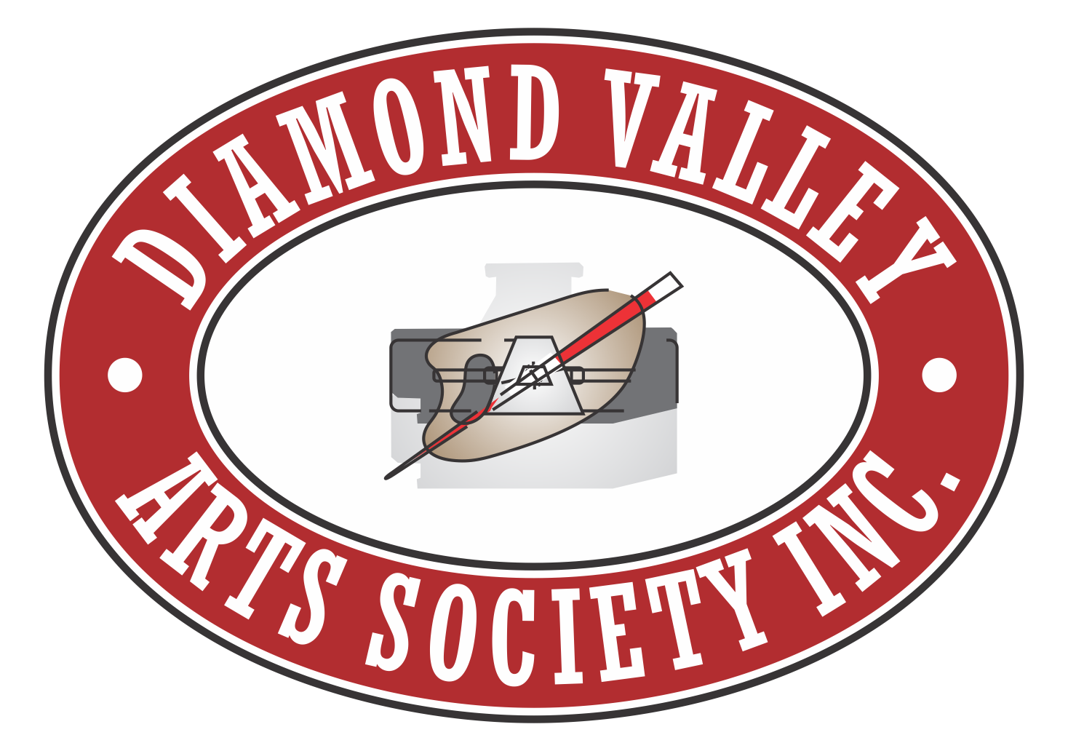
PO Box 171
Greensborough Vic 3088
www.dvartsociety.com.au
Show Convenor – Diane Gardner - 0409 016 695
Anna Dalton - 0400 343 859

Melbourne International Flower and Garden Show March 25 – 29, 2020
Hi members,
The Melbourne International Flower and Garden Show entry time is coming up and the Diamond Valley Arts Society has again been asked to participate in their show. The show runs from Wednesday 25th March to Sunday 29th March.

If you could please return your entries as soon as possible it would be appreciated.

Attached is an entry form if you would like to enter your paintings. Thousands of people come through the show and our society sells a good number of paintings.

Please take note of the closing date and time, delivery date and time and also pickup date and time.

Please make sure that you have met the hanging requirements. Any painting without ”D” hooks and wire, or not wrapped and in a bag with your name on it will not be accepted to be hung at the show.

Regards
Diane Gardner or Anna Dalton
0409 016 695 0400 343 859

